Git:
Git is a distributed version control system(DVC). A DVC helps a software team to manage changes to source code overtime.
Git is responsible to keep track of changes to content (usually source code/file).
It provides mechanism for sharing contents with others.

Git-Hub:
Git-Hub is a company which provides Git repository hosting. It is a web page on which you can publish Git repositories and collaborate with other people.
Git hub stores locally the changes you commit, then if you push the commits, it also stores them remotely.

Benefits of Git-Hub:

- Provides a backup of your files.
- It gives you a visual interface for navigating your repositories.
- It makes repositories collaboration easy due to the multiple collaboration of people to the same project.
- Provides a light weight tracking system.
- It can test changes to your code without using the original.
- It can revert back the changes to old version of code.

Basic Commands and Concepts:

-Installation command in terminal: (apt-get install git)

- Connection commands:
git config –global user.name”EhtishamNasirg”
git config –global user.”e12099b@gmail.com”
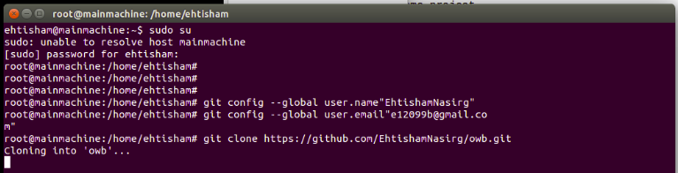

- git clone: >makes a copy of a repository.
>Stores the repository in you computer.
>A “fork” creates your own copy of someone else's >repository(collection of files and folders tracked by git).
(git clone <repository link/name>)
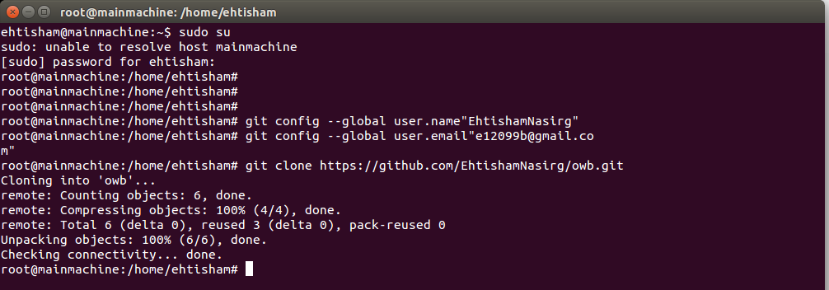

creating new file in the repository:
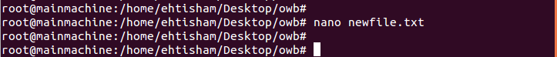
editing the file:
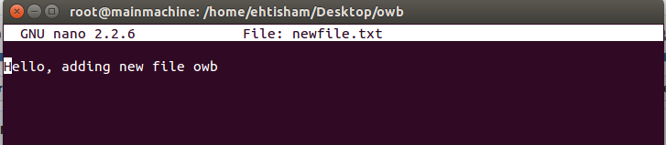

- git add: >After cloning, you can change the repository code or edit the source file and then save the changes you made to a cloned file.

(git add <file name.format>) or
(git add .)-> adds all untracked files
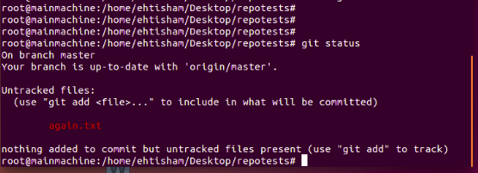
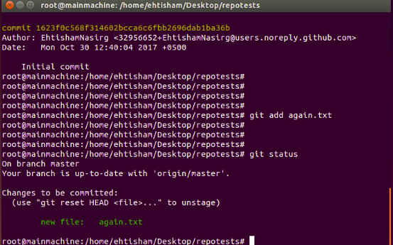

- git commit: provides a summary of the changes you made in the respected repository
(git commit -m “message”)
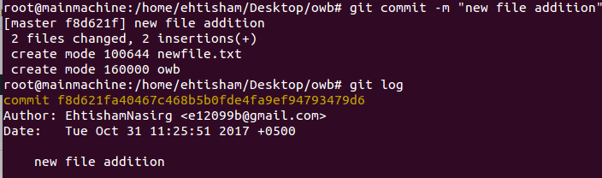
- git status: shows current status of the repository.

(git status)
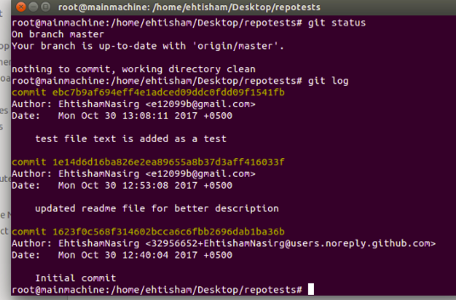

-

git push: updates the changes made to a cloned repository.
(git push -u <origin master>) -u is used for saving
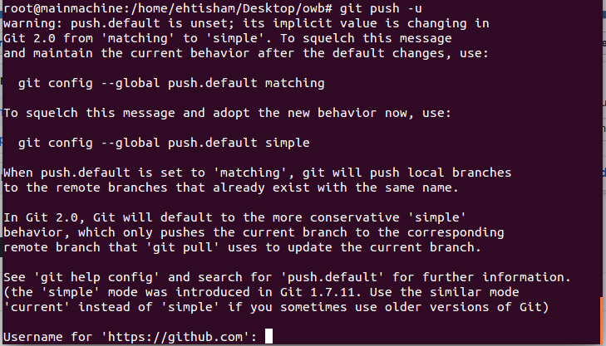

- git pull: provides the latest repository available on Git-hub
(git pull <origin master>)

- git log: shows the changes made in the repository
(git log <repository name>)
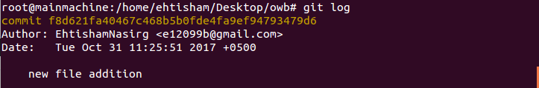

- git reset: The repository goes back to a previous version
(git reset -–hard <commit>)
(git reset -–hard <origin/master>): reverts back to remote repository version/current version on Git-Hub.
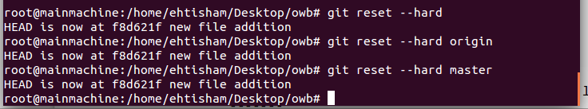
- git diff: shows all the changes made to the file/repository
(git diff <filename>)
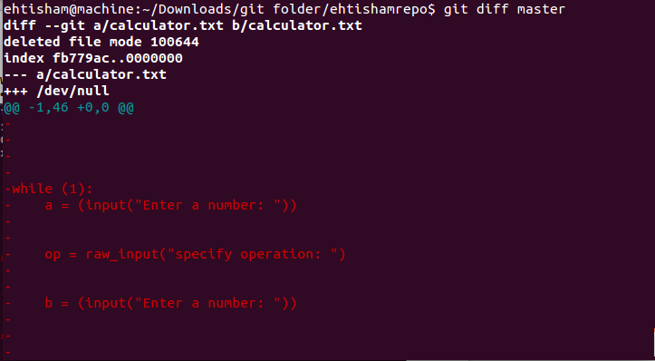

- Merge conflicts: When two different people makes a change to a same repository at the same line a merge conflict occurs.
This merge conflict needs to be resolved to upload the authentic repository.

<<<<<<<<<< (Head)
-------
------- Changes you made
-------
==========
-------
------- Changes from the hub done at the same line
-------
>>>>>>>>>>>(Tail) 546869--- (conflict commit)

- Branching: >Allows to have a different couple of versions of code
>Keeps original repository safe.
>When you are confident, then you can update the master branch
>Each branch has its own branch history and current version.

Commands

- git branch: Shows all branches of a repository and also tells the number of branches and gives you current branch name.
(git branch <branch_name>): creates a new branch.
(git branch -D <branch name>): Deletes a branch.

- git checkout: Switches to the new branch made.
(git checkout <branch_name>)
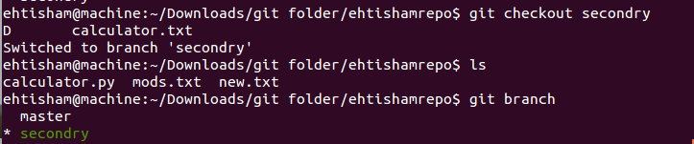
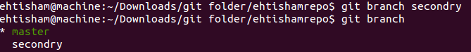

(git checkout -b <branch name>): Creates new branch and switches you to it.
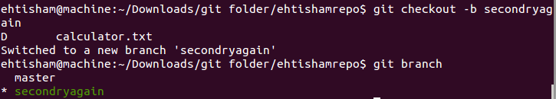

- Delete branch: (git branch -D <Branch Name>)

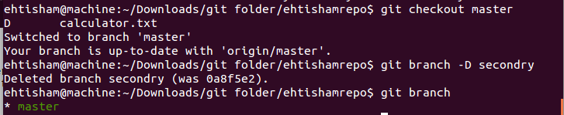

- git merge: Merge two different branches together, This is where a merge conflict could occur
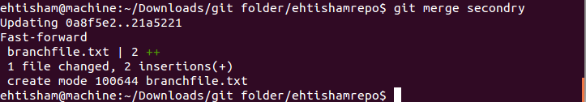
OUTPUTS AT GITHUB
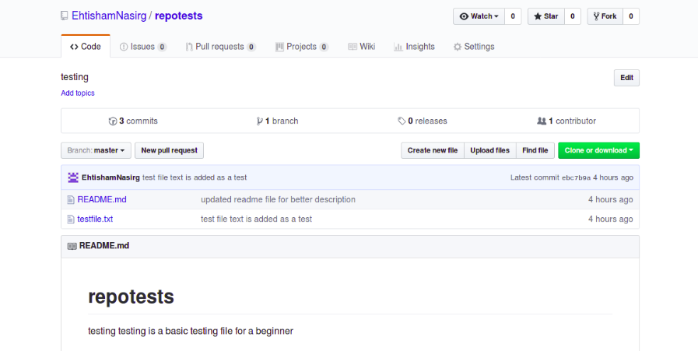

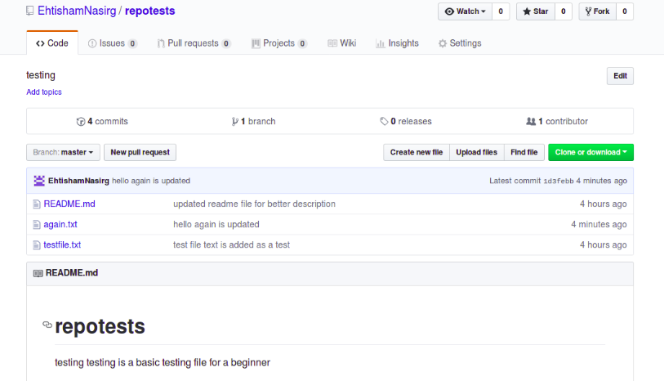
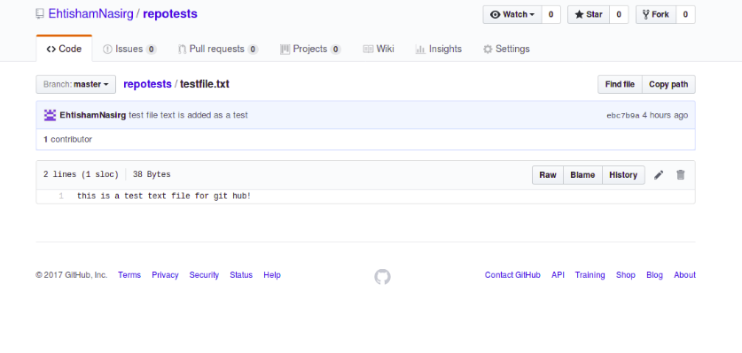

SSH key Login Method

Ssh key Generation:

Command: $ ssh-keygen -trsa
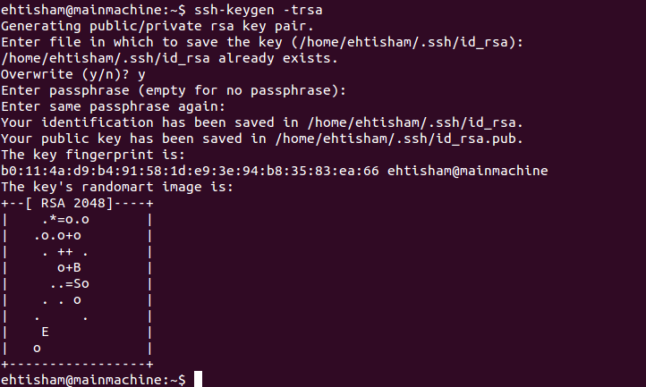

key destination: $ cat /home/username/.ssh/id_rsa.pub

-The key starts from “ssh-rsa” and ends at machine host name.
-Save the key in a text file for you own convenience.
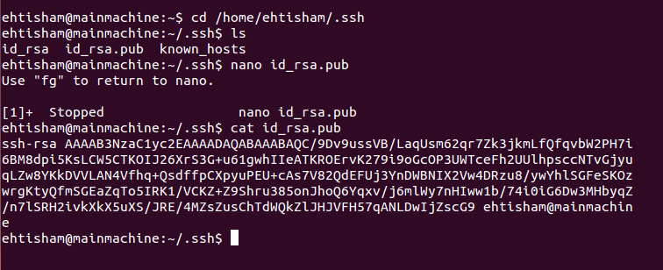

-Now got to github.com or gitlab.
-Switch to settings at top right corner options.
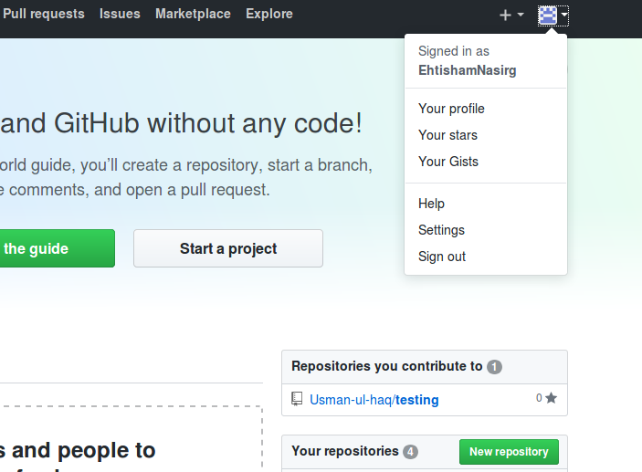

-Look for ssh key.
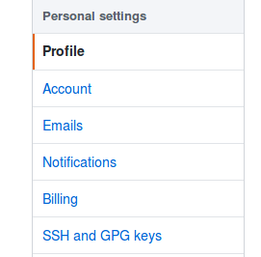

-Add your generated key in the space given there and save.
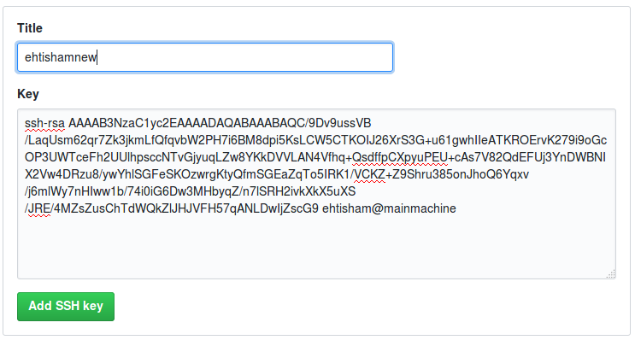
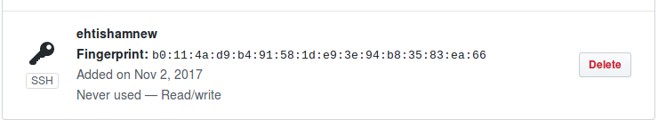

-Now you can use gitclone and add the ssh link of your repository mentioned in you github/gitlab account.
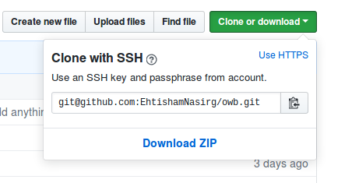

-Through ssh, you will not be prompted to provide the username, email or password while performing any operation in git.
